Prototype-Midterm

 

|  |  |
| --- | --- |
| **Student Name/ID Number:** | Syukur Sidiq Nur Alam / BDSE-0922-089 |
| **Academic Year:** | 2022 |
| **Unit Assessor:** | Arvinder Kaur |
| **Project Title:** | Transforming Business Models in the Digital Era to Address Post-Covid Challenges. |
| **Issue Date:** | 16 September 2023 |
| **Submission Date:** | 14 September 2023 |
| **Internal Verifier Name:** |  |
| **Date:** |  |

|  |
| --- |
| **Learner declaration** |
| I certify that the work submitted for this assignment is my own and research sources are fully acknowledged.  14/09/2023  Student signature: Date: |

**A summary of the project's objectives, scope, and requirements, as outlined in the project brief or proposal.**

These components include the introduction and integration of a new software system into the existing infrastructure, with a primary focus on enhancing operational capabilities and efficiency. The project also involves seamless data migration from the current legacy system to the newly implemented software, ensuring data integrity and completeness. To facilitate a smooth transition and optimize the use of the new software system, comprehensive training programs will be developed and delivered to end-users, along with ongoing user support for addressing queries and issues. Furthermore, continuous maintenance and periodic upgrades of the new software system are crucial to maintaining its long-term functionality, security, and alignment with evolving organizational needs. The project's objectives are to improve the accuracy and efficiency of the customer data management process, increase the speed of customer data retrieval, reduce manual data entry and management efforts, and enhance the quality of customer service, all of which align with the broader goals of digital transformation in the post-Covid digital landscape.

**A brief description of the technologies, programming languages, and frameworks used to develop the website.**

The website development leverages WordPress as the content management system, while the programming languages employed include HTML, CSS, and PHP. Framework-wise, WooCommerce is utilized to enhance e-commerce functionalities, and Essential Addons for Elementor augments the capabilities of the Elementor page builder for dynamic and interactive content creation. These technologies and programming languages collectively contribute to the website's development, ensuring a feature-rich and user-friendly digital presence.

**Design and other design assets that illustrate the website's layout, color scheme, typography, and overall user interface design.**

**Landing Page**

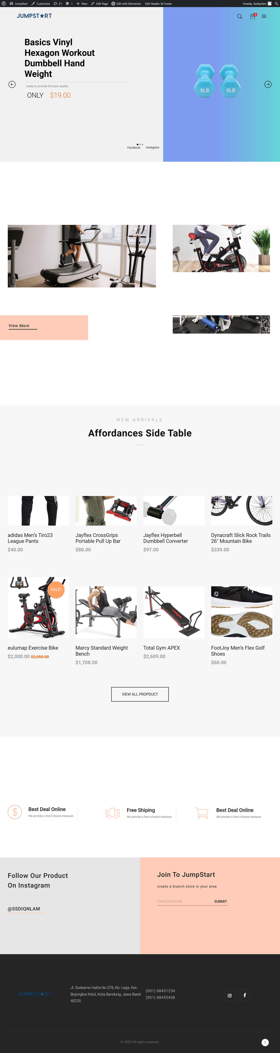

**Cart Page**

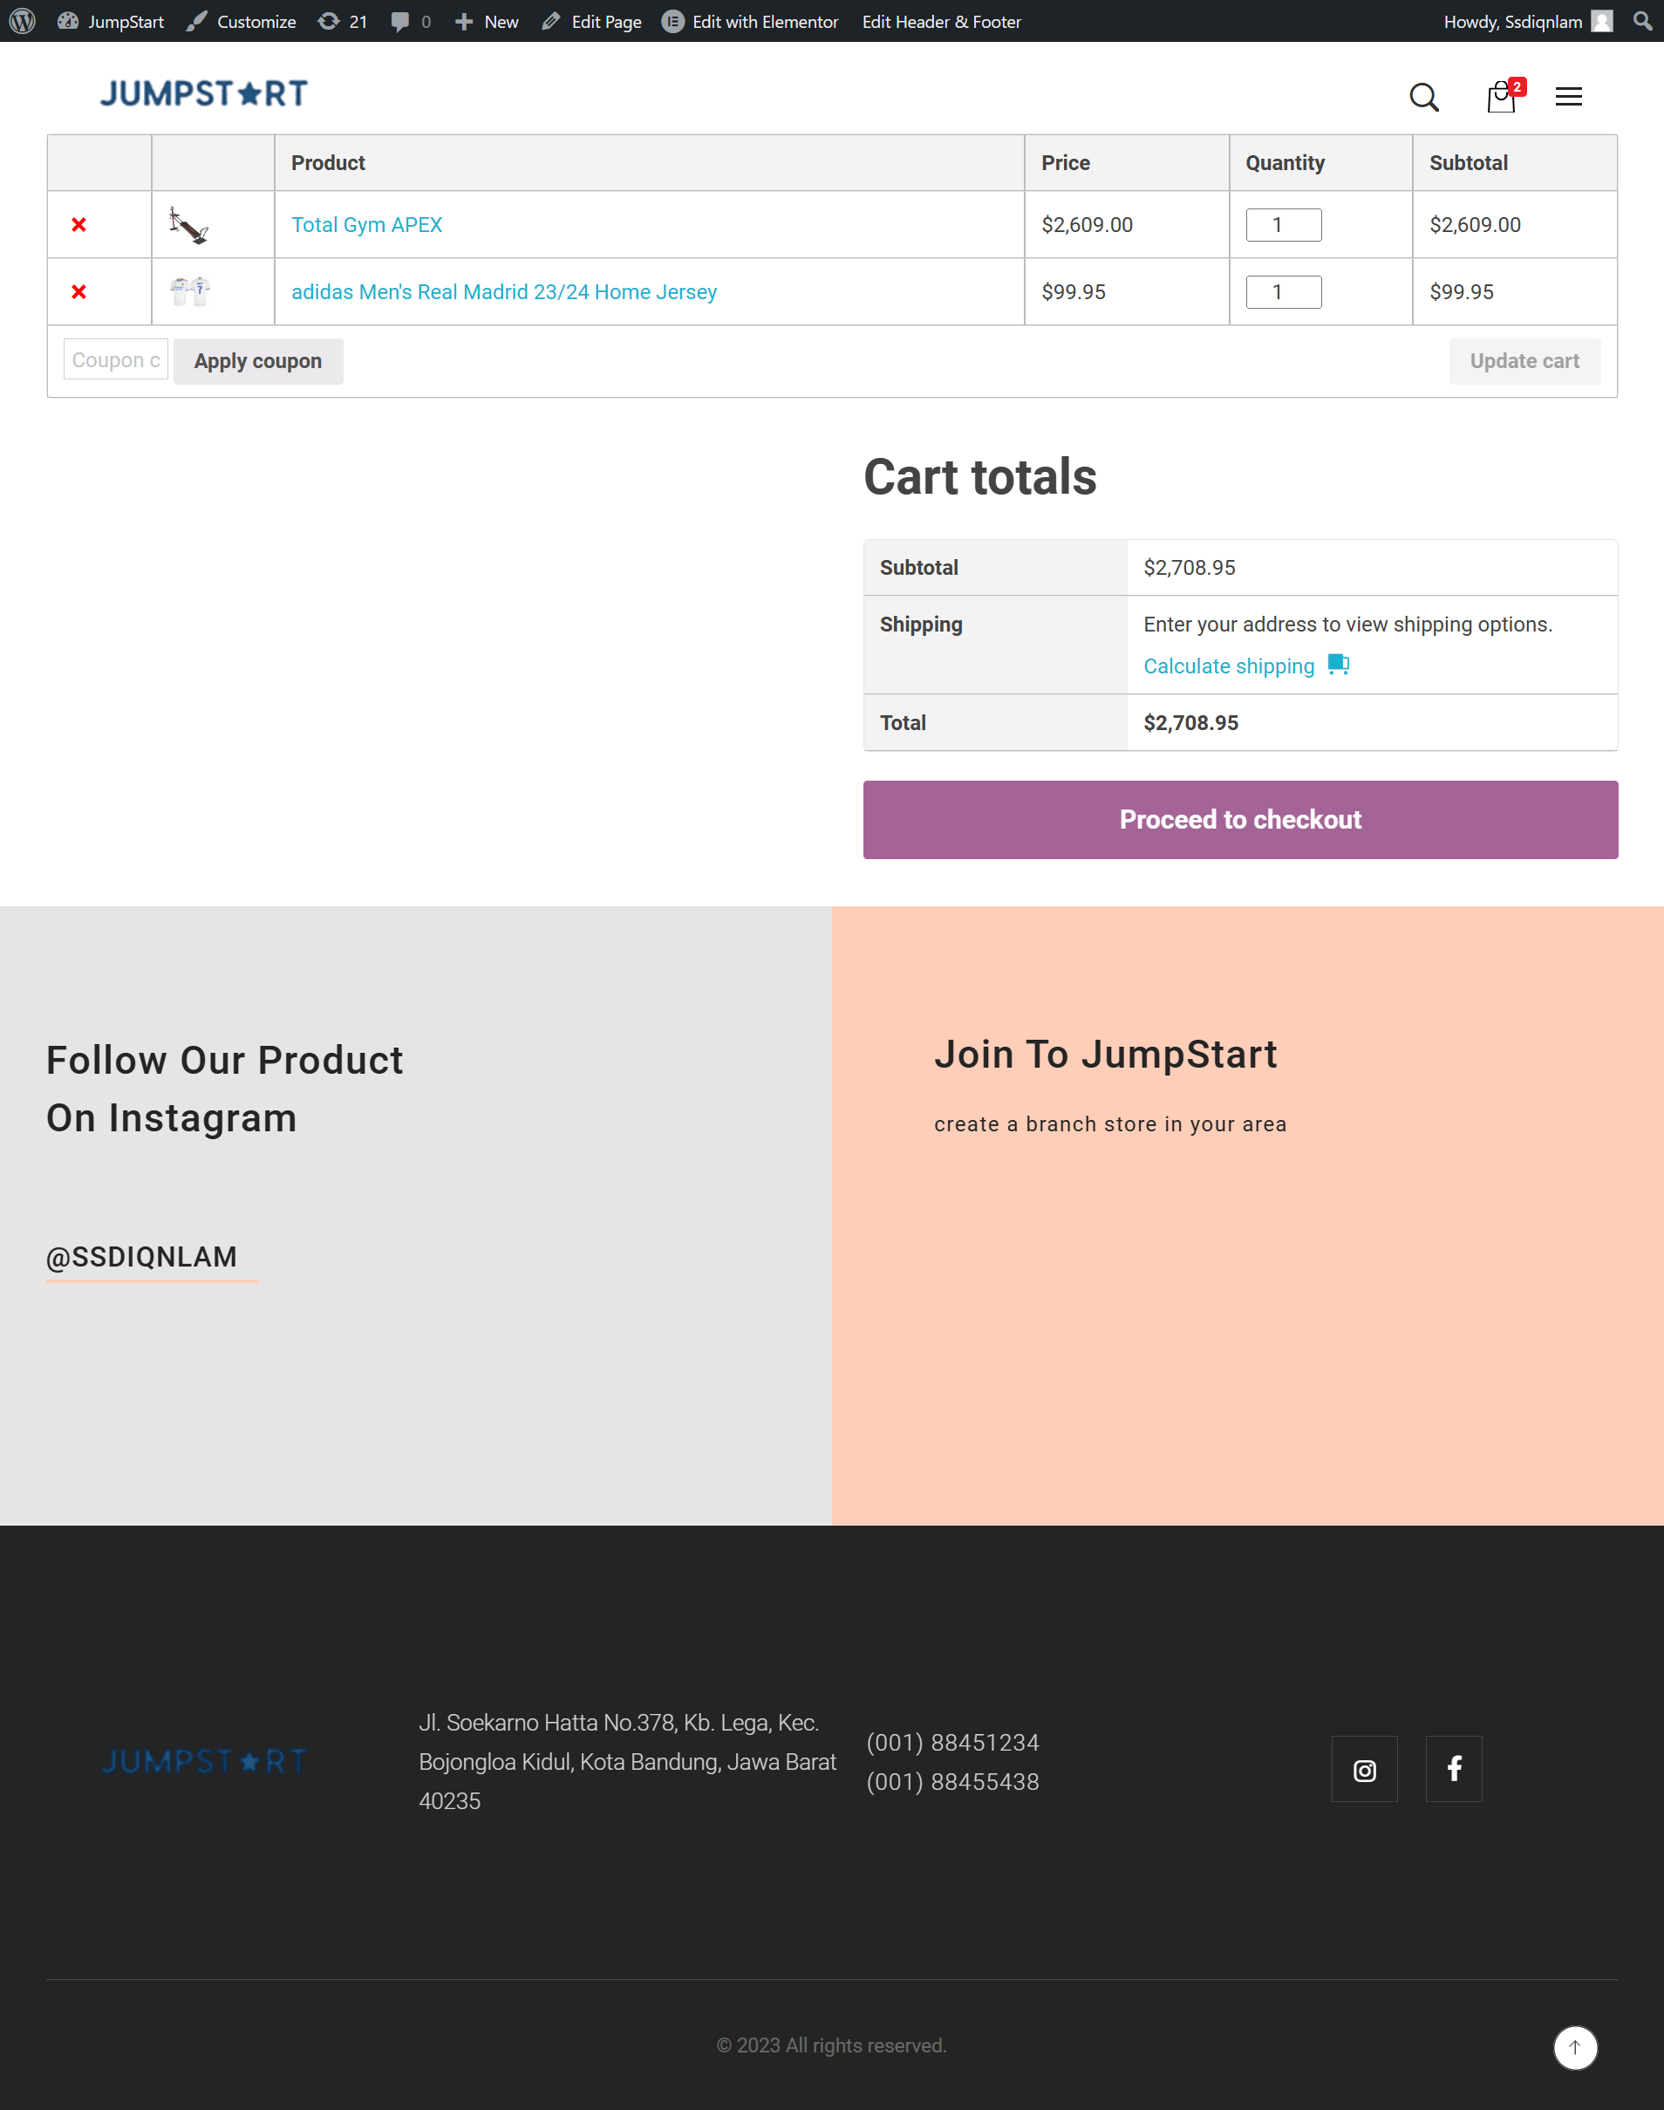

**Shop Page**

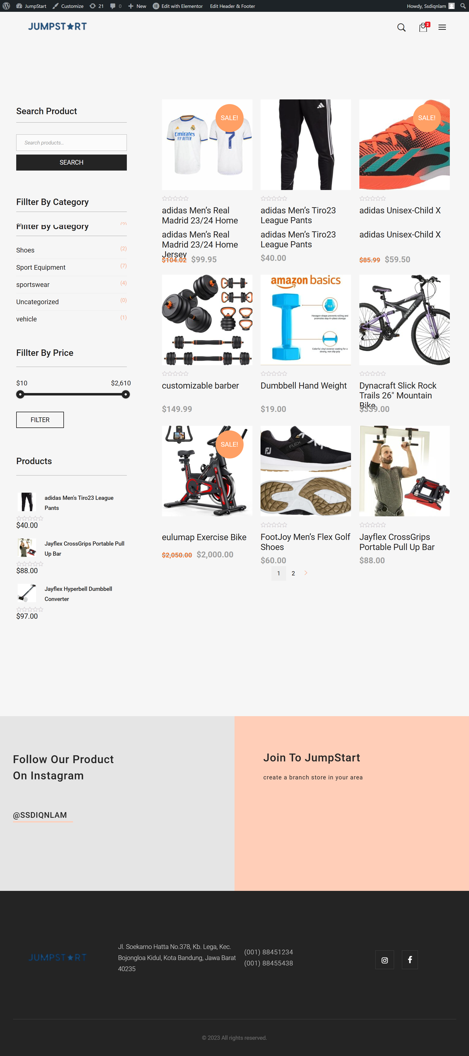

**Detail Product**

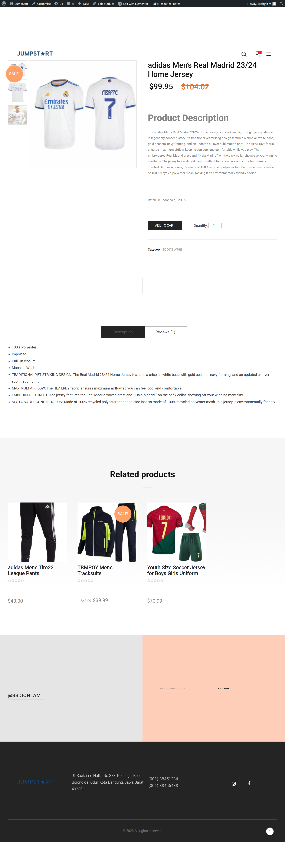

**About Page**

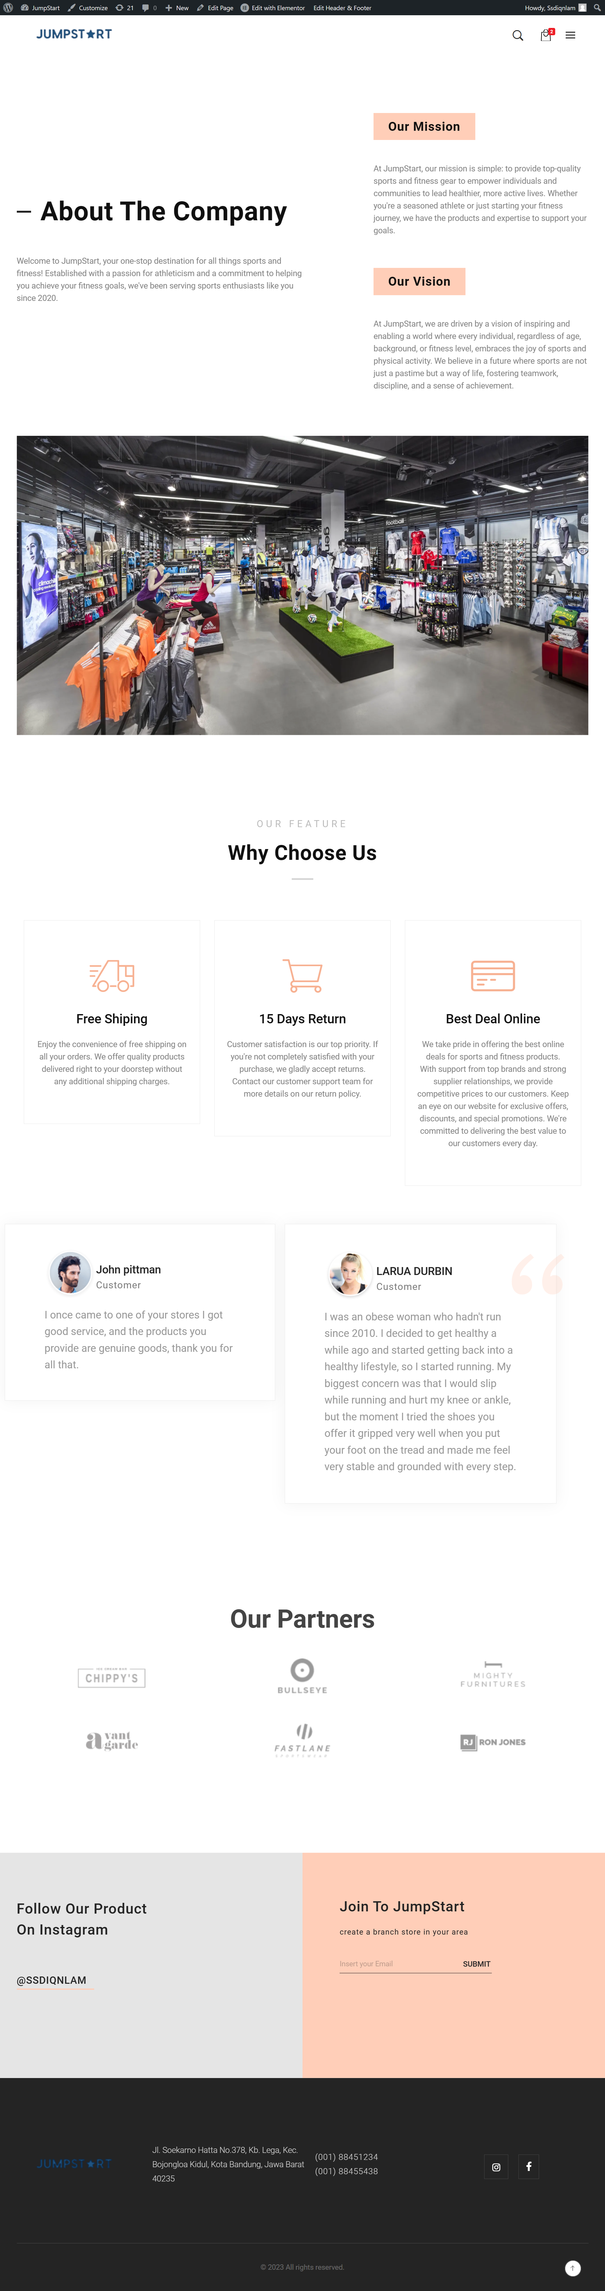

**Contact Page**

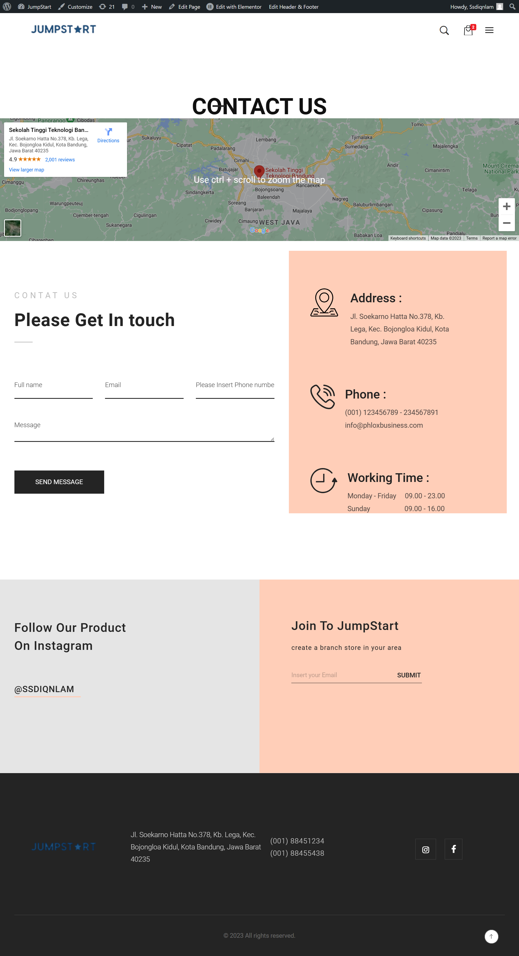

**Login Page**

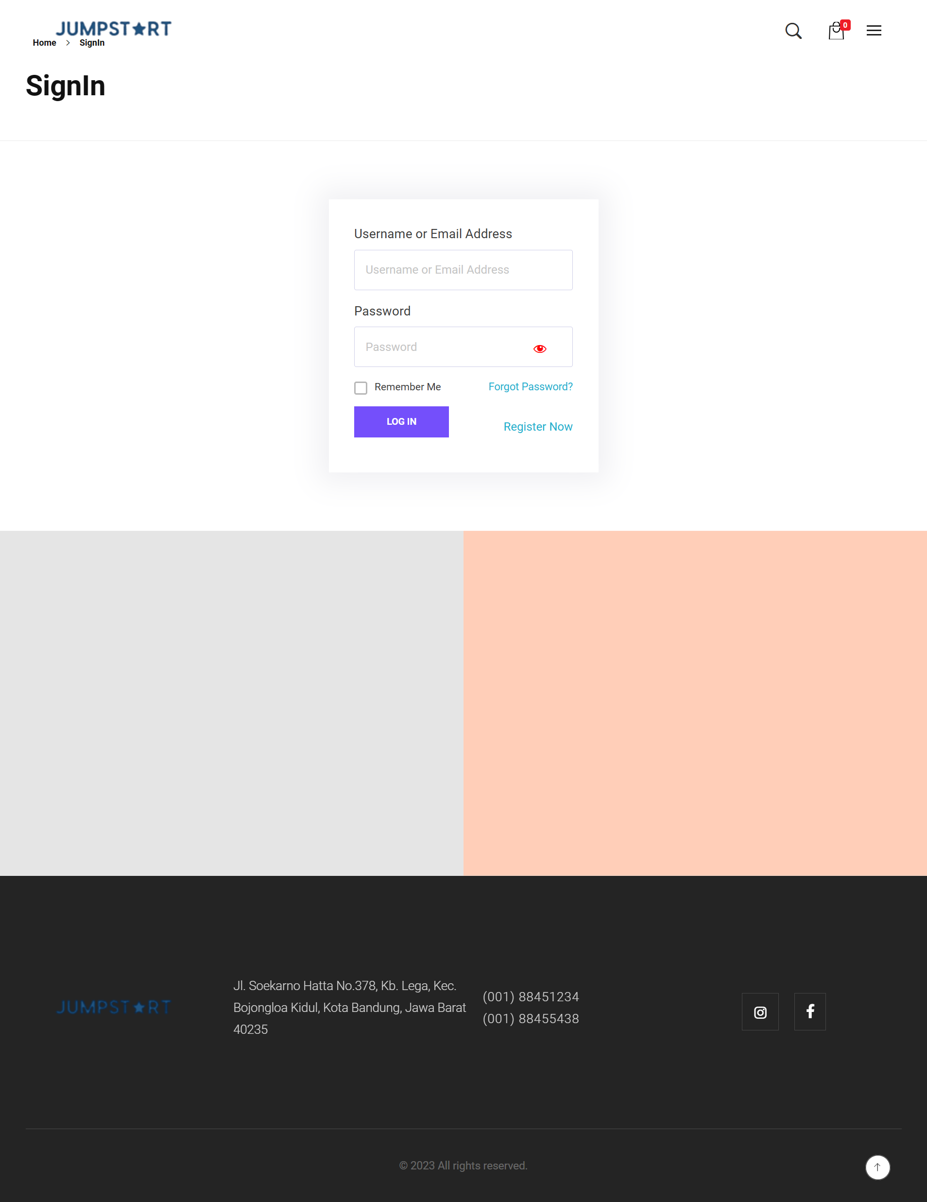

**A description of the website's core functionality and features that have been implemented so far, along with any that are planned for the remaining development period.**

1) Register: This function enables consumers to open a fresh account on the online store. Individual details like a user's name, email address, and password can be entered. Once their registration has been successful, they can log in to their account.

2) Login: Using this feature, people who have registered can access their accounts by logging in with their email address or previously-registered username and password. This enables access to exclusive areas and account-related features.

3) Users can view a list of the products that are offered on the e-commerce site using this function. Every item typically has an image, a description, a price, and a button to add it to the shopping basket.

4) Product List Category: This function allows customers to browse products according to particular categories. When users choose a category, the app will show a selection of products that fall within that category, including products for men, women, and accessories.

5) Add To basket: This function enables customers to add the products they have chosen to their shopping basket. Prior to placing items in the shopping basket, users can choose how many of each item they want to buy.

6) Add Product - Admin: This function enables store owners or administrators to add new products to the online store. The administrator will enter the product's details, including its name, description, image, price, and other pertinent data. This makes it possible to efficiently add to and manage the inventory of products.

**Feature to be implemented**

1) Checkout: The customer can start the checkout process after choosing the things they want to buy and adding them to their cart. This procedure entails entering shipping information, choosing a payment option, and verifying the order before completing the transaction.

2) Select a Shoe Size: If you offer shoes or other products in several sizes, this function is particularly useful. Before placing the item in their shopping basket, users can select the size that best meets their needs.

3) Logout: When a user is done shopping or wants to leave the platform, they can log out of their account using this feature. To keep the user account secure, this is a crucial step.

4) Manage Customer/User - Admin: With the help of this feature, administrators or store owners can control the customer or user data that has been registered on the e-commerce platform. Administrators can manage client data generally, see and change information about customer profiles, and set access restrictions.

5) Manage Product - Admin: Administrators can control products on the e-commerce platform using this function, "Manage Product - Admin." Product categories can be managed, stock information updated, prices and product descriptions changed, and products added, edited, or deleted by administrators.

6) Manage Order - Admin: With the help of this capability, administrators can control orders that have been placed by consumers. Administrators can confirm orders, process shipments, monitor a list of incoming orders, and manage order status up until completion. This facilitates effective order tracking and fulfillment.

**Sample code snippets and database schemas that showcase the website's back-end functionality.**

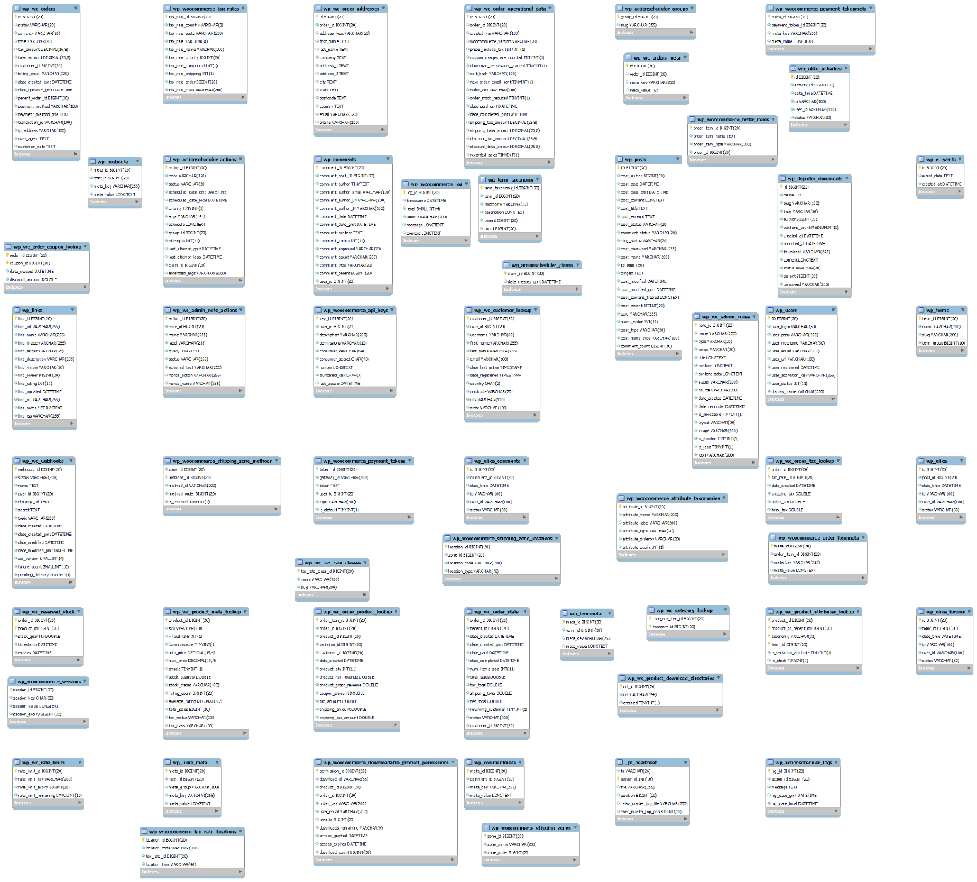

**Index.PHP**

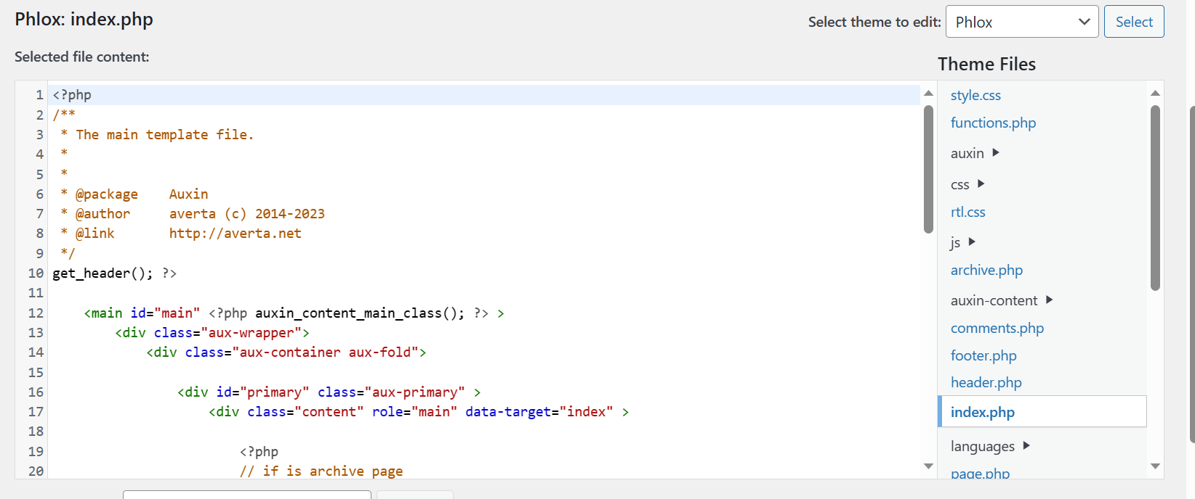

**Header.php**

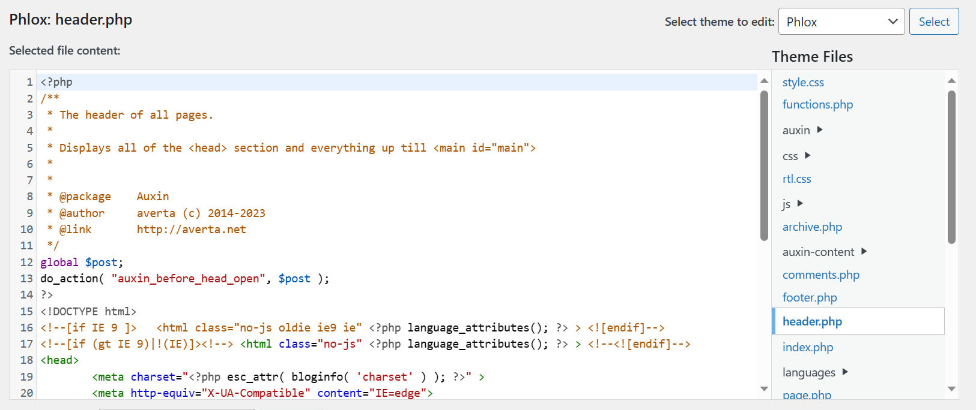

**Footer.php**

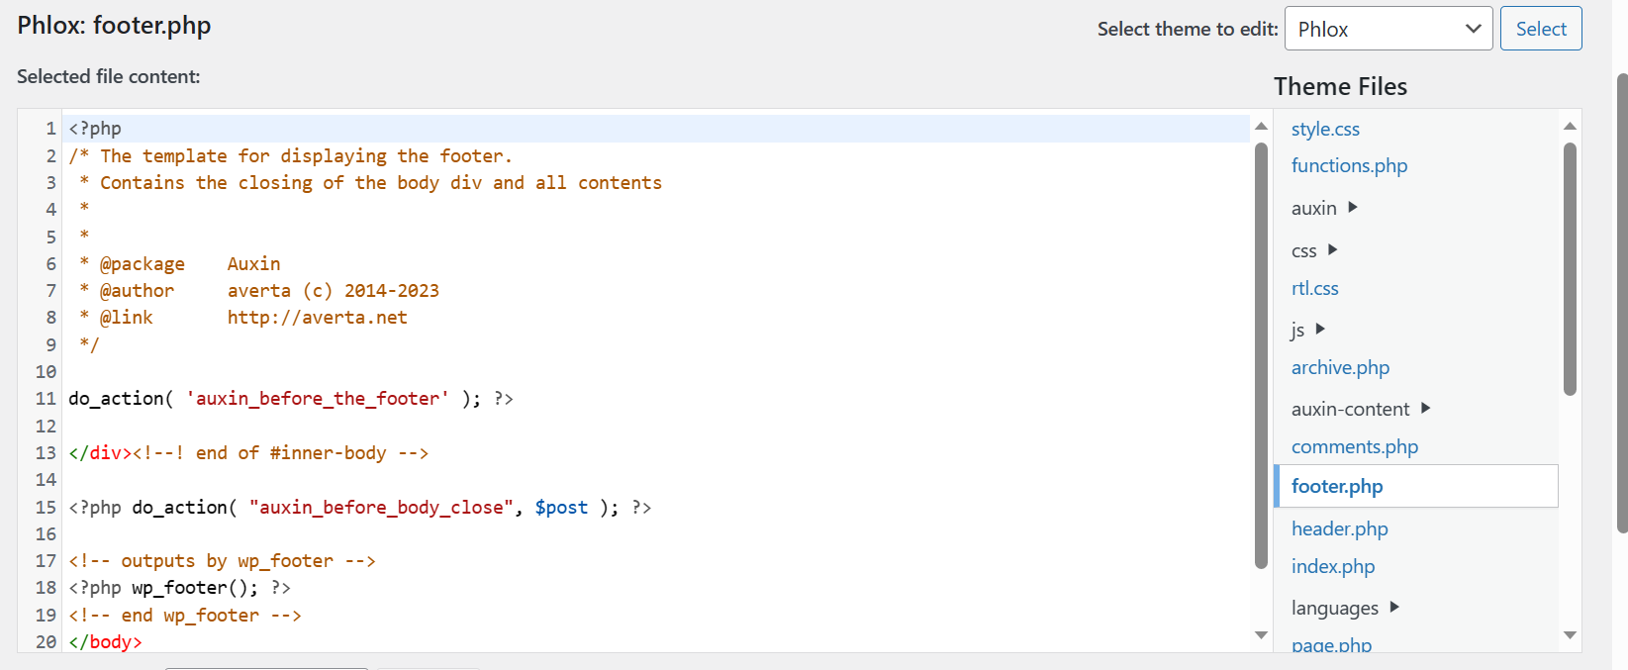

**Search.php**

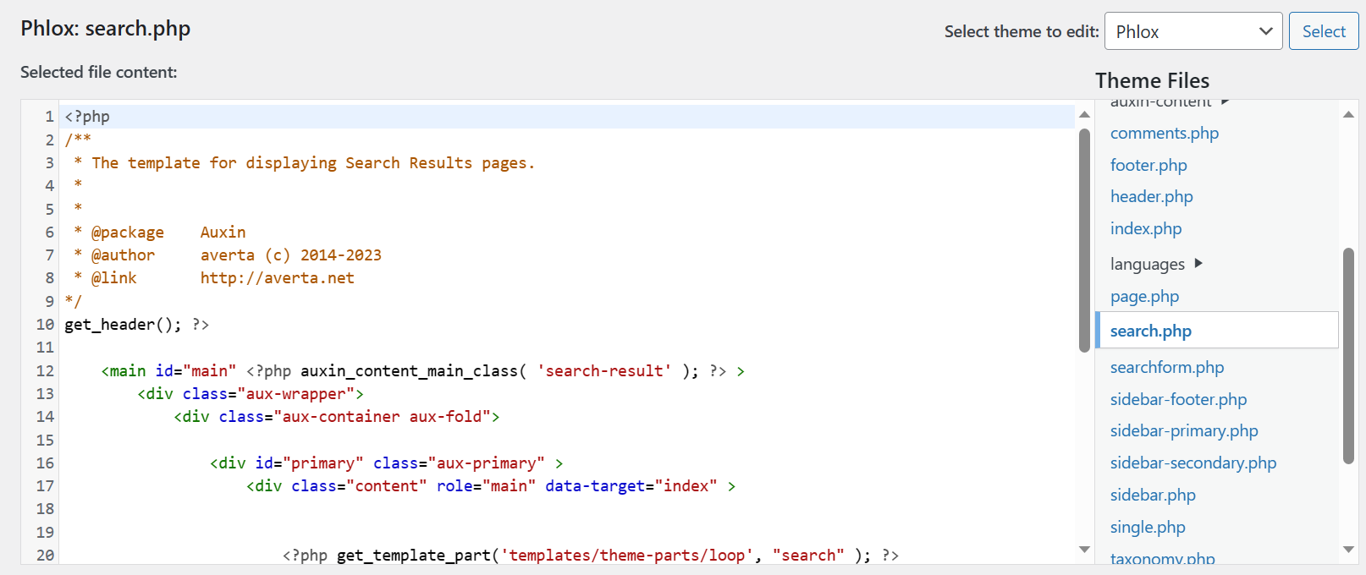

**A detailed roadmap or timeline for the remaining tasks and deliverables, along with any changes or updates to the original project plan.**

